Shared Fences Ecosystem Map
Trent Mckenzie, Shikhar Shrestha, Jathin Bokkisam

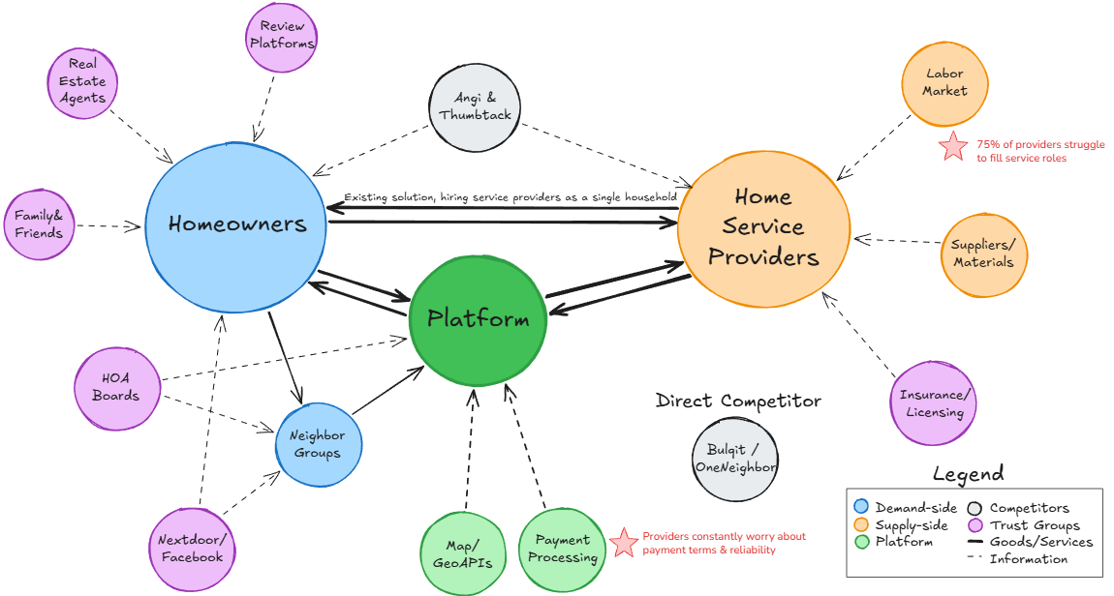

Supporting Narrative
Our ecosystem focused on the relationship between homeowners & home service providers. This view includes both the demand side (homeowners, neighbor groups, and choice influencers) and the supply side (service providers and their operational dependencies, including labor availability, materials, and insurance). On the services side, labor & payments are key factors (red stars). Most service providers also struggle with seasonality & struggle to accurately predict demand. On the demand side, homeowners use different methods to source service providers, only 31% of homeowners say it is “very easy” to locate qualified professionals. Lead-generation services indirectly raise service prices for homeowners & the quality of recommendations is varied and inconsistent. Our human-centered design intervention opportunities start on the design side. (1) Why do homeowners choose the provider they ultimately choose? (2) How do they decide what time to hire a provider (especially for non-critical services)?

